

Freq_LF_HF 5 MHz
-
Freq_LF_VHF 210 MHz

User’s manual

March 2021

Presentation 3
Introduction 3
Annotated View 4
Measuring a frequency 5
Displaying the frequency 5
Power good 5
Selecting the parameters 6
How to use the buttons 6
Menu tree 6
Choosing a frequency band 7
Choosing the resolution 7
Calibrating the device 7
Choosing the measurement type 8
Storing a reference frequency 8
Displaying the reference frequency 8
Applying an operation to the measured value 8
Energy Economy 9
Programming 10
The Library 10
Sending frequency values though I2C example 12
Troubleshooting 13
Lack of precision 13
The board is not working 13
No measurement available 14
Limitations of use 15

Presentation

Introduction

This board was conceived to offer as much precision and versatility as possible while using the microcontroller Atmega328p to count frequencies.

Using this microcontroller allows to build a device totally compatible with the Arduino technology :

- It is programmable within the Arduino IDE that uses a language close to C++
- Allowing to use USART, I2C, and SPI interfaces

Here are the specifications

 | Freq_LF_HF 5 MHZ | Freq_LF_VHF 210 MHZ
Minimum frequency | < 5 Hz
Maximum frequency | > 5 MHz | > 210 MHz
Maximum amplitude | 30V peak to peak
Input | 1 MOhm, 30 pF  ESD protection 30 kV 200W
Sensitivity | < 180 mV R.M.S.
Resolution | Up to 7 digits
Time base | TCXO +/- 1.5 ppm / frequency and +/- 2.5 ppm / temperature
Calibration | Automatic @ 4 or 10 MHz, or manual
Measurement modes | - Automatic  - Within a specified band
Measurement types | - Frequency  - Period
Operations | Storing of a reference frequency and displaying of :  - Frequency – ref frequency  - Frequency + ref frequency  - Ref frequency - frequency
Power voltage | 7.5V to 12V
Current consumption | Working : around 80 mA  Sleeping : around 20 mA
Environmental standards | - Automatic sleep mode  - ROHS

Annotated View

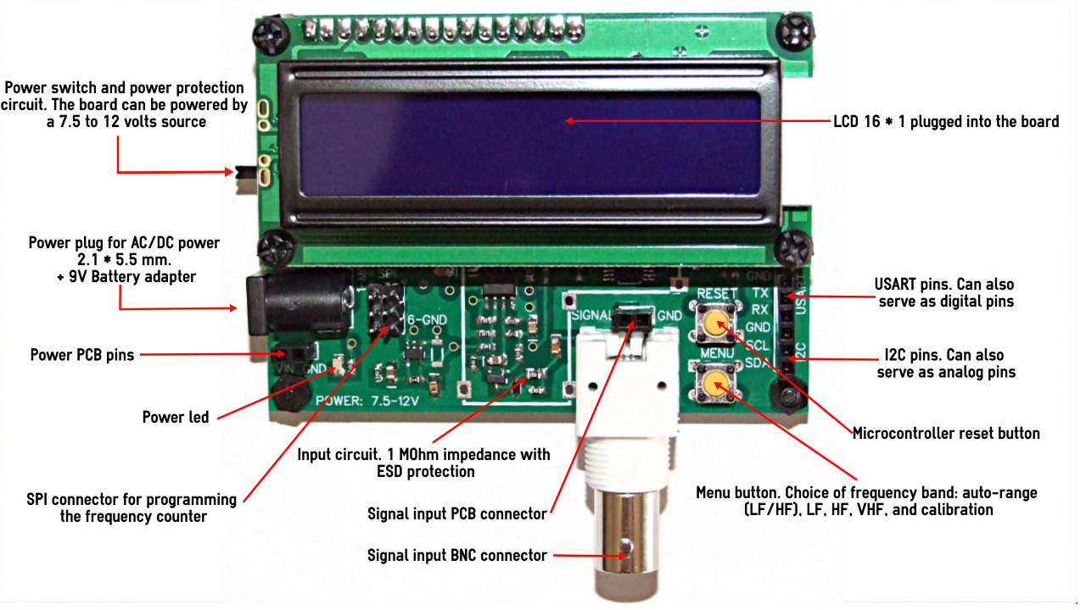

On the left of this picture and from top to bottom :

- Power switch
  - Power connector of type « DC005 » to plug an AC/DC transformer or another power source
  - Just below a two-pin female connector to plug « Dupont » wires to power the board
  - The power LED that should lit when the power switch is on (toward the bottom)
  - The 6 pin ISP connector

On the middle :
- The input circuit
- Signal input BNC connector
- Just above it a two-pin female connector for the signal input, but preferably not for VHF signals.
- The RESET button
- The MENU button

On the right from top to bottom:

- Rx and Tx USART pins
- SCL and SDA I2C pins (no pullup)

Measuring a frequency

You need to :

- Plug the signal
  - Into the BNC connector
  - Or into the 2 pins above it

- Power the board either on the two pins or the DC005 power connector from an AC/DC transformer delivering between 7.5V et 12V ( > 200 mA) or a 9V battery or another relatively quiet power source.

- Switch on the device (toward the bottom). The LED should lit. If the voltage is not within specifications an error message « POWER TOO HIGH » or « POWER TOO LOW » is displayed. A too high voltage might harm the circuit and a too low voltage might give false measurements.

- The measurement begins in « AUTO » mode. After a few seconds the frequency is displayed. If the device could not measure a frequency the message «No measure avail» is displayed.

Displaying the frequency

Measurements are printed on the LCD like :

10.0000 MHz AUT

10.0000 The frequency, with a resolution depending on the frequency and the chosen resolution

MHz the measurement unit

AUT : the chosen mode or band
AUTO: automatic
LF: Only within the 5 Hz – 5 KHz band
HF: Only within the 5 KHz – 5 MHz band
VH1: Only within the 4 MHz – 22 MHz band
VH2: Only within the 22 MHz – 210 MHz band

If there is a specified operation done on the measurement, it is the operation type that is displayed instead of the band.

Power good

The power voltage is periodically tested.

If the voltage is too high, it might harm the circuit. Hence the error message “POWER TOO HIGH!“ is displayed.
If the voltage is too low, the board performance might decrease. The error message “POWER TOO LOW“ is displayed.

Selecting the parameters

How to use the buttons

There are two buttons on the board, marked:

« RESET »: to reset the board in the typical Arduino style.
« MENU »: to access the menu, navigate and select parameters values.

To enter or leave the menu or select a parameter value : hold your pressing on the button.

To navigate to a next value : click on the button.

Menu tree

Frequency band >
AUTO
5 Hz - 5 KHz
5 KHz - 5 MHz
4 - 22 MHz
22 - 210 MHz

Resolution >
LOW
NORMAL
HIGH
ULTRA HIGH

Calibration >
Cal 4 MHz (press)
Cal 10 MHz (press)
Cal manual >
Cal: cal value

Display f/p >
Display frequency
Display period

Store (press)

Retrieve (press)

Operation >
Annul op.
VFO+IF
VFO-IF
IF-VFO

Sleep >
Sleep 30 s.
Sleep 5 m.
Sleep disabled

< Exit menu

Choosing a frequency band

The menu entry Frequency band > allows to select the automatic measurement mode or will narrow the measuring within a specific band. It might be useful to select a specified band if

- The measurement is wrong in automatic mode
- Or to measure with HIGH or ULTRA HIGH resolutions, since they are not selectable in AUTO mode

Choosing the resolution

The menu entry Resolution > allows to select a resolution level. This will determine the number of displayed digits.

This table shows the number of displayed digits depending on the frequency and the chosen resolution:

Resolution | Frequency
 | F < 1 KHz | 1KHz <= F < 10 KHz | 10KHz <= F < 100 KHz | 10KHz <= F < 1 MHz | F >= 1MHz
LOW | 3 | 3 | 4 | 4 | 4
NORMAL (1) | 4 | 4 | 5 | 5 | 5
HIGH (2) (3) | 5 | 5 | 6 | 6 | 6
ULTRA HIGH (3)(4) | 6 | 6 | 7 | 7 | 7

- The default resolution on AUTO mode
- The default resolution on band mode
- HIGH and ULTRA HIGH can’t be selected when in AUTO mode
- When selecting ULTRA HIGH resolution, the acquisition time lasts several seconds

Calibrating the device

The precision of measurements depends on the precision of the time base, that is a 16 MHz high precision TCXO (+/- 1.5 ppm / frequency , +/- 2.5 ppm / temperature). Other sources of error also accumulate and some users might want to get the best precision possible. So, it is possible to calibrate the device :

- By measuring a very precise 4 MHz signal. This will give the best calibration.

Plug the high precision 4 MHz signal on the device’s input. This reference frequency should be as good as possible (with an error below +/- 1 ppm) and an amplitude between 1 and 3 volts. You only need to press the MENU button when it displays Cal 4 MHz (press). Once the calibration is done, if the measured value is too different from 4 MHz, the calibration fails, otherwise the calibration coefficient is displayed for a short time.

- By measuring a high precision 10 MHz source.
Proceed like with a 4 MHz signal.

- Or by manually selecting a compensation value within +/- 10 ppm by 0.5 ppm steps.

The current calibration value is converted in ppm and displayed when pressing the menu button while the menu entry Cal manual > is displayed. Then, each click on the button will increase the value by 0.5 ppm. When the maximum value is passed, it will go back to the minimum value. After selecting the desired value, press on the button. It is up to you to compute the compensation value in ppm by measuring a known frequency and computing the deviation with the displayed value.

Example:

- Plug a signal of, as an example, 100 MHz frequency
- Select the measurement band from 22 to 210 MHz and the ULTRA HIGH resolution
- Select the manual calibration value of 0 ppm
- Leave the menu and wait for the measurement value to remain constant +/- 1 unit
- Write down the measured value, for example 100.0004 MHz
- The compensation value is 1000000 * (1000000 – 1000004)/ 1000000 = -4 ppm
- In the Cal man menu, click until displaying -4 ppm
- Leave the menu
- The displayed value should now be 100.0000 MHz plus or minus one unit

Choosing the measurement type

The menu entry Display f/p allows to choose to display either the frequency or the period (1 / frequency) expressed in seconds.

Storing a reference frequency

If you would like to store a reference frequency that you will add or subtract to the measured frequency, plug this frequency, wait for the display to remain constant then go into the menu and press Store (press).

Displaying the reference frequency

You can check the stored value after pressing on the menu entry Retrieve (press).

Applying an operation to the measured value

Instead of displaying the measured frequency you can display the result of the operation:

- VFO + IF
- VFO – IF
- IF – VFO
- Or cancel any operation

By selecting the appropriate value in the menu Operation >

Energy Economy

The board allows to save some energy when there was no measurement done for some time. The board goes to sleep mode after a selectable delay of 30 seconds or 5 minutes. It can also be deactivated.

When the frequency counter goes to sleep, it displays « Energy economy » for a short time then shuts down most circuits. It is woken up when pressing the MENU button or by communicating on a communication port.

Programming

The needed programming resources and this user’s manual are available at https://github.com/mrguen/Freq_LF_VHF

The frequency counter is programmable like an Arduino UNO board. The bootloader was already loaded. You only need to select the Uno board type in the Arduino IDE.

Of course, most pins are used by the frequency counter. But all communication ports are still available, that is :

Protocol | Microcontroller pin | Arduino pin number | Function
SPI | PB3 | 11 | MOSI
 | PB4 | 12 | MISO
 | PB5 | 13 | SCK
USART | PD0 | 0 | RX
 | PD1 | 1 | TX
I2C | PC4 | 18 | SDA
 | PC5 | 19 | SSCL

To program the board, you have to:

- Launch the Arduino IDE
- Select the menu Tools > Board> Arduino AVR Boards > Arduino UNO
- Power the board
- Plug an USB / Serial adapter on the pins marked TX, RX, DTR and GND, make sure the Rx and Tx cables are inverted between the board and the adapter.
- If your adapter is properly configured in your system, the device should be listed as a COM port and within the Arduino IDE in Tools > Port : COMxx
- Open the default program that is available on https://github.com/mrguen/Freq_LF_VHF , named « Freq_LF_VHF_v1.0_programming.ino »
- Load the program by pressing on the « arrow » button within the Arduino IDE is toolbar

The Library

The « Freq_LF_VHF_v1.0_programming.ino » sketch includes the minimum program needed to run the frequency counter, without any modification.

To work it needs to load the library « #include <Pandauino_Freq_LF_VHF.h> ».

This library defines a C++ class and an instance of this class, named « frequencyCounter ».

It is possible to invoke a couple of public functions and properties. The default program calls

- freqSetup inside the void setup() {} loop
- freqCount inside the void loop() {} loop

A couple of parameters are enumerated:

boardType, runMode, measurementMode, measurementBand, measurementResolution, measurementDisplayType, operationType, sleepMode.

To know the possible values of these parameters, read the file « Pandauino_Freq_LF_VHF.h »

Here is the list of public functions and properties of the frequencyCounter object :

FUNCTIONS

void configureComputation(measurementMode, measurementBand, measurementResolution);

To call after modifying the measurement mode/band (Auto or specific band) or the resolution to ref-configure the board. It will also start the appropriate frequency computation algorithm.

void stopComputation();

Stop the frequency computation algorithm.

void freqSetup(boardType, bool _outPutToSerial = false, long _bauds = 57600);

Initializes the board depending on its model (up to 5 MHz or 210 MHz) and activates the serial output with the bauds value passed as a parameter.

void freqCount();

Checks if a measurement value is available and prints it.

double getFrequency();

Allows to get the last measured raw frequency value.

double readFrequency();

Allows to get the last measured raw frequency value. Then the value is set to 0 so the user will know when a fresh value is computed.

void standbyMode();

To put the board into sleep.

void beginSerial(long);

Starts the Serial communication with the bauds value passed as a parameter.

void endSerial();

Stops the Serial communication.

void calibrate(long);

Launches the automatic calibration for the frequency passed as parameter.

For example, calibrate(1000000) ; launches a calibration over a reference frequency of 1 MHz (to plug into the signal input).

PROPERTIES

static sleepMode sleepSetting;

Sets the delay before the boards goes to sleep if there isn’t any measurement done. The parameter is an enum value.

static double calibration;

Defines the calibration coefficient. All measurements will be multiplied by this value.

For example1.000002.

Sending frequency values though I2C example

The directory /examples/Freq_LF_VHF_v1.0_I2C_communication includes two Arduino sketches to send frequency values from the frequency counter to another Arduino compatible board (Nano, Uno etc) and to print the value on another LCD and the Serial Monitor.

You will need to:

- Connect together the SCL and SDA pins of the frequency counter, acting as I2C master, and the other board acting as I2C slave.
- Add pullup resistors (1 to 10 KOhm) to the 5V rail on each SCL and SDA lines.
- Load the sketch Freq_LF_VHF_v1.0_I2C_master.ino on the frequency counter.
- Load the sketch Freq_LF_VHF_v1.0_I2C_slave.ino on the receiving board.
- Connect the LCD (optional) to the slave board pins (see https://core-electronics.com.au/tutorials/use-lcd-arduino-uno.html)

If the values are not printed you might need to reset the frequency counter.

Troubleshooting

Lack of precision

If the measurements are not good enough, you should check that :

- The signal is not too noisy. If it is noisy it should be filtered in a low pass filter with a cut-off frequency a little above the supposed frequency.

- Cabling to the frequency counter :
  - Use the BNC connector and a shielded cable
  - If you can’t, use a twisted pair of cables. In many case it will be good enough up to the MHz range.

- The signal’s amplitude should be above the sensitivity threshold defined in the specifications. The precision might decrease for low amplitude signals at very high and very low frequencies.

- The board is linked to a good ground. The ground of the board and the signal source should be the same.

- The power voltage is high enough. Use a low noise power supply if you want to get the best resolution.

- The board should not suffer mechanical vibrations.

- It should be exposed to a significant electrostatic or electromagnetic field.

- It is not working outside of the 0 to 40°c temperature range.

The board is not working

If the boards seems to not work at all.

- Check that the power switch is on.

- Check that the LED is lit. If not, there is a problem with the power supply or power circuit.

- Check that it is not in sleep mode. Click on the MENU button or the RESET button.

- Check that the power voltage is good at the two power connector pins it should be within 7,5V and 12V

- Check this voltage at the pin 1 of the regulator located at the bottom left of the board (component with 3 pins on the top and 2 pins on the bottom. Pin 1 is at the top right.) If there isn’t any voltage it might be that the polyswitch tripped and is now blocking. Let it cool down. There might be a shortcut somewhere. Check that you did not connect something that is making a short-circuit.

No measurement available

If the board is working but does not show any measurement value :

- Check that the signal does arrive to the board. If necessary, use an oscilloscope at the input pins.

- Check that there is a 6,7 voltage at pin 5 of the regulator situated at the bottom left of the board (pin 5 is the bottom right pin).

- If this voltage is not present, check that there are 5 volts at pin 3 of this regulator (the top left pin).

- If the voltage is 5 volts, the regulator might be burned.

- If all this is ok check that there is a signal at the pin 12 of the microcontroller. This is the 12th pin starting from the pin identified by an engraved point and courting counter clockwise. If there isn’t any signal the signal conditioning circuit is faulty. Check the solder joints.

Limitations of use

This electronic board is conceived to be included in the user’s own project or appliance. It was not conceived to be part of a specific circuit or machine.

It should never be part of a circuit that uses signals with an amplitude above 30 volts peak to peak.

It should not be powered with a voltage outside of the 7,5 to 12 volts range.

It is not a toy. It should not be used by a child.

Whenever you throw it in the bin, use only an appropriate garbage collecting circuit for electronic or electric appliances. It should not be thrown out with the usual trash.

